**Teletherapy Specs and BRD**

**What is tele-therapy?**

Tele-therapy is mental health counseling over the phone or online. In the current live version, we have this functionality in the menu with the title "therapist"

**What do we mean when we say "Tele-therapy" revamp?**

In this revamp project we will focus on mainly UI + some minor tweaks to make the therapist booking process smoother and simple.

**Why are we doing this revamp?**

We have never touched the "therapist section" in the past 3 years, UI is quite old and does not match with the rest of the app. Above all these, the booking process itself is very tedious and visually unpleasing. In order to resolve all these issues, we are making UI revamp.

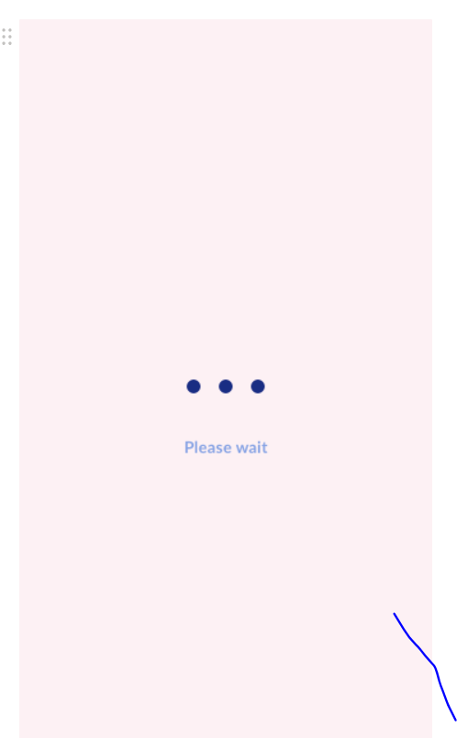

The moment user will try to access the "therapist" section they will see this loading "GIF" screen. This GIF will run for "X" seconds. After this user will land on therapist listing screen.

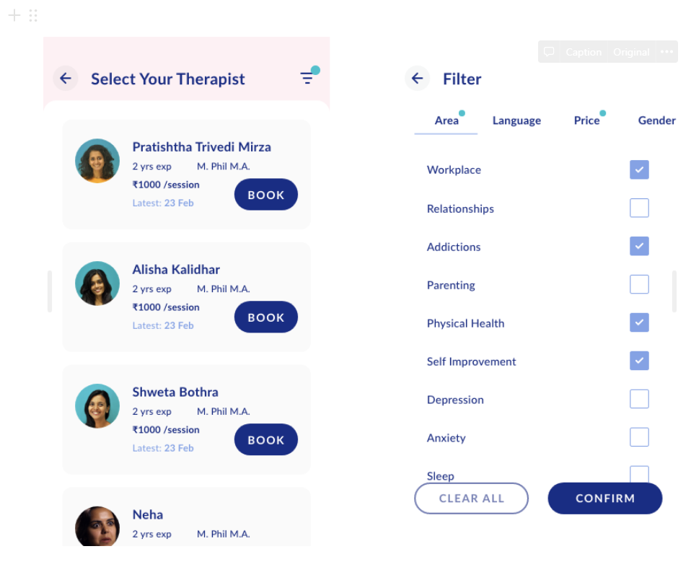

A you can see, after loading the screen user will lad on this "therapist listing" screen. As you can see on the top there are two icons.

**"Back"** This icon will take the user back to the source screen. Same action can be performed by clicking on "Android back" button.

**"Filter"**

As you can see in the top right corner, we have this "filter" icon. Clicking on that will open the second screen. It's a simple flow where you can select options by clicking on the checkboxes and can de-select them by clicking on the checkbox again.

This screen has been divided into four categories

1. Area
2. Language
3. Price
4. Gender

Now, if you select any filter from any category that particular category will be marked with the blue dot, to let user know that they have selected some filters from particular category.

In the bottom we have two CTAs.

1. Clear all
2. Confirm

"Clear all" will clear all the filters will clear all the filters. Before clearing all, it will show one pop up and confirm about whether the user wants to clear all filters or not.

"Confirm" will close take the user back to the listing page with all the applied filters.

**Select your package**

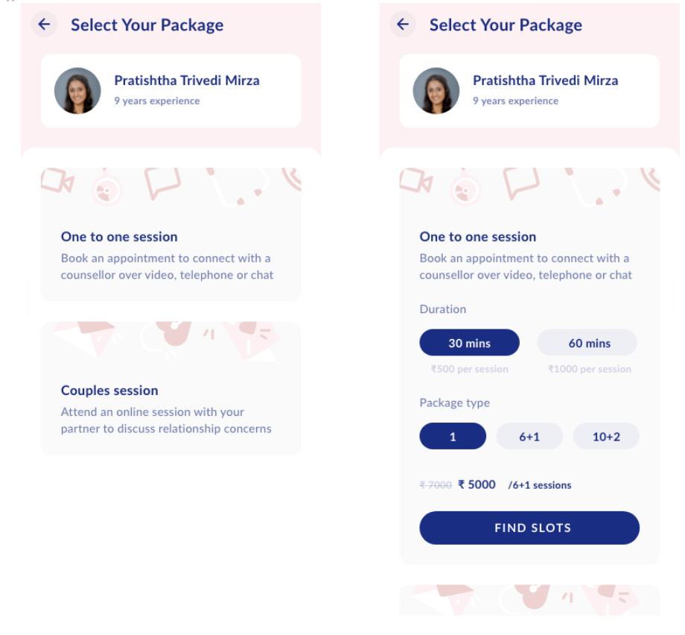

Clicking on "Book" CTA will open this screen. On this screen user can select the package. Clicking on that package will open the details about that package, from which user can select their preferred options.

As you can see the therapist card here in the top section, clicking on this card will open the therapist details page. This screen will have all the details about the therapist and back CTA. Back CTA will take the user back to the source screen

Clicking on "One to one" session will open the dropdown which will have two subsections.

1. **Duration** This section helps user to select the time for one session. This section will have two options: 30mins, 60mins. By default, 60 minutes option will be selected and the user can change that.
2. **Package type** Right now we are offering 3 packages: 1, 6+1, 10+2. By default, "1" option will be selected. Just below the package section user can see the total price as well (including discounts)

On this screen this CTA will be dynamic and not static.

**Find slots**

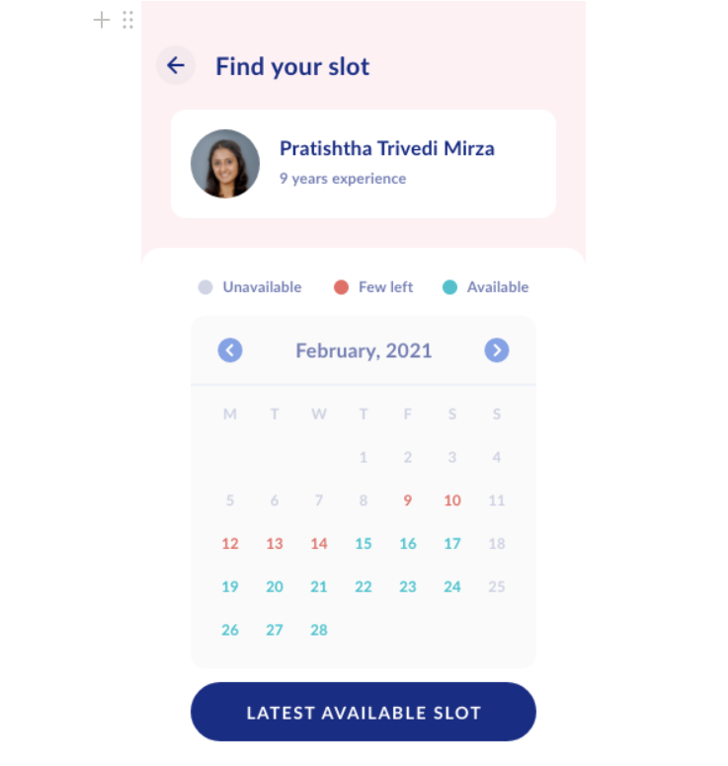

Clicking on "Find slots" will bring the users to this screen. In the top part you have therapist card, this functionality will remain the same.

Below the therapist card, we have listed tags for different stats for availability. Currently, we are going with 3 tags in total: Unavailable, Few left, Available.

In the calendar section, we have few functionalities which are pretty straightforward. On top, we have arrows, through which users can switch months. User can not go in the past. Dates will be marked inappropriate colors to let the user know which dates are available and which are not. Clicking on that date will take the user to that particular date, and will show the appropriate results.

At bottom we have CTA "Latest slot available". Clicking on this CTA will take the user to the "Find your slot". App will show the immediate available slot on that screen

**Available Slot**

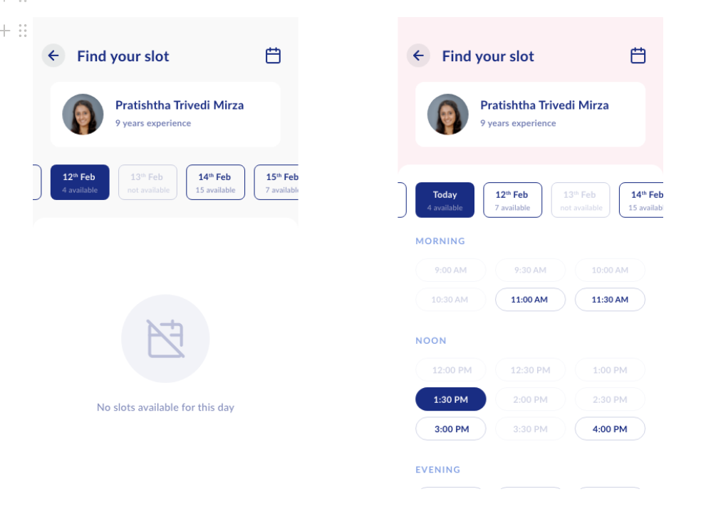

As you can see depending on the date app will show the appropriate screens. In top bar we have "Back" icon, which take user back to the previous screen. In the right corner we have calendar icon which will open the calendar from the bottom. This calendar will help user to navigate more fast. Below that we have therapist card, which will work as mentioned earlier.

Just below the therapist card, we have date wise calendar through which users can navigate day by day. Each day will have the no. for slots available as mentioned in the wireframe. This date-wise calendar will have a horizontal scroller and users can scroll it as much as they want.

We have categorized these slots into three categories so that users can understand these slots properly. Morning, noon, evening. This categorization will be provided by the content team.

Functionality of this screen is quite simple. Clicking on any chip will select that slot and clicking on it again will deselect the slot.

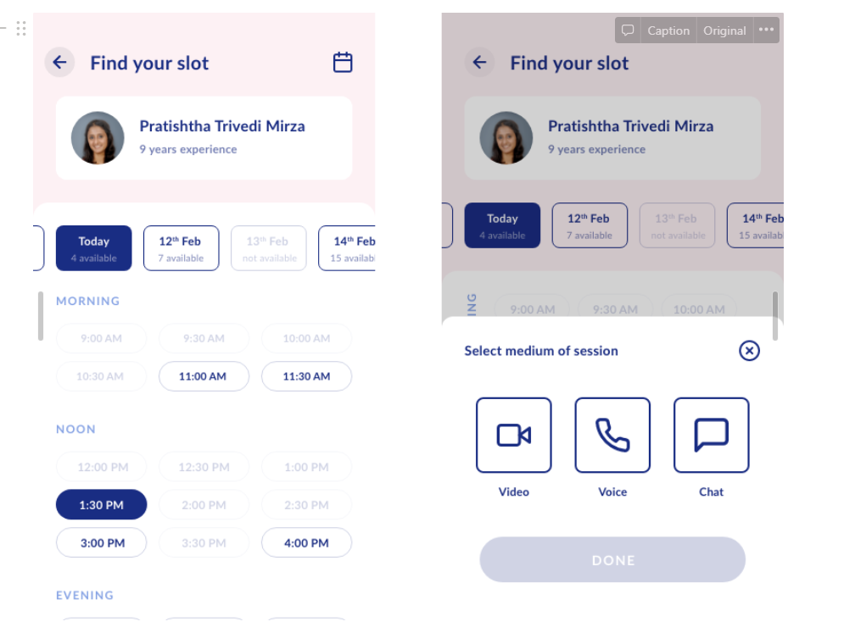

Once the user has selected the slot, it will open the bottom sheet. This bottom sheet will have three options.

1. video
2. Voice call
3. Chat

User can select from any of these mediums. Once user selects the option that "DONE" CTA will get activated. On top right corner we have "cross" icon as well, which will close the bottom sheet. If user clicks on any other part of the screen then also it will close the screen.

**Booking summary**

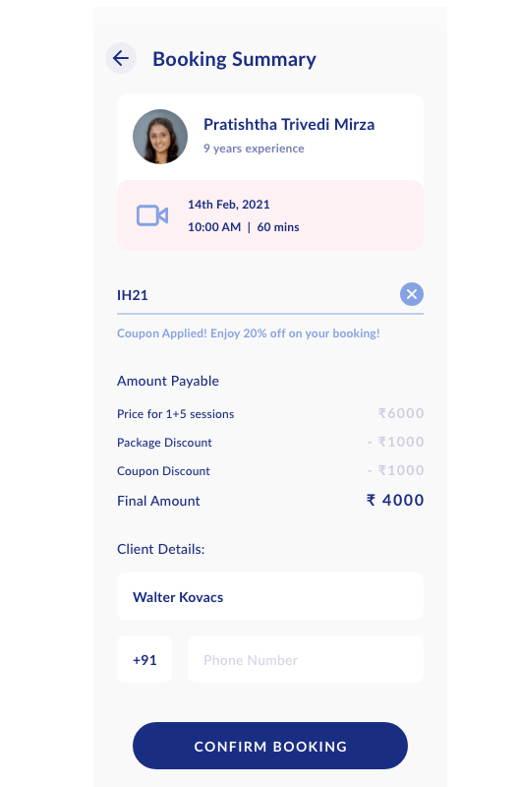

As you can see, this screen pretty simple, on top we have basic functionality. Below that we have section for coupon code. Functionality of this feature is also pretty common and same as selling screen.

Amount payable section will give you all the details about the amount you need to pay.

Below that we have client details, where users can write the name and phone number. If the user has already added a mobile number in the profile section then that number will be prefetched on this screen. Once the user has entered all the required detail then only this CTA will get activated. Here this CTA is also dynamic and will scroll with the screen. Clicking on this screen will open the third-party app for the payment.

* 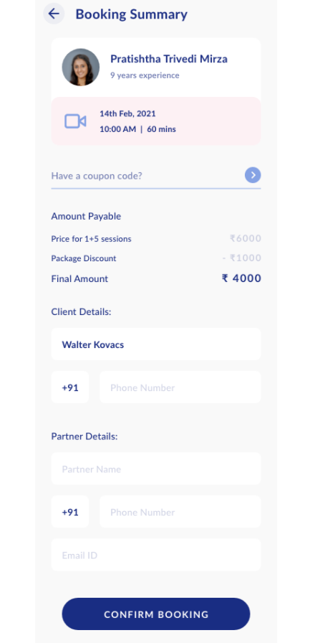

In case of couple's session user needs to add partner's details as well.

**Therapist feature after booking**

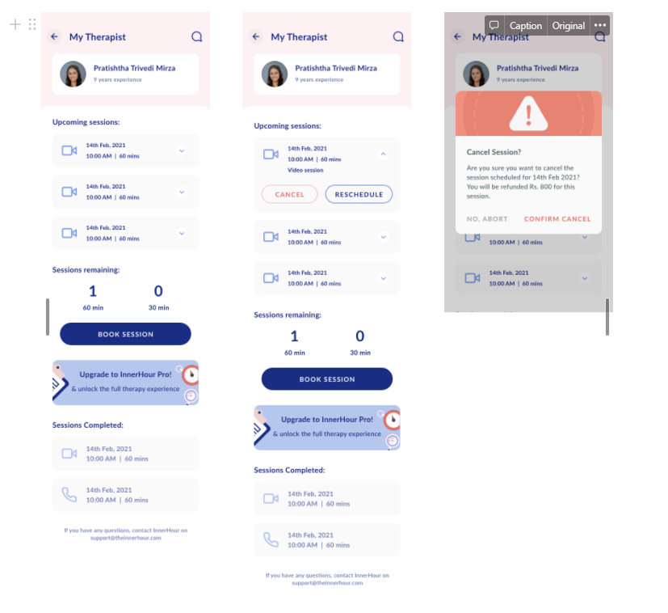

Once the user has booked the session > and clicks on the "Therapist" option from the menu bar then the user will get this screen. On top, we have a "chat" section through which users can send and receive messages from the therapist. If user will get any message from the therapist, they will receive, some notification on the chat bubble itself.

**Upcoming sessions**

In this section user will have only upcoming sessions listed, clicking on this card will expand with 2 other options "Cancel" & "Reschedule". "Cancel" will open one popup for confirmation. Thhis will have 2 CTAs. "Yes" will cancel that slot. "No" will close the pop-up.

Clicking on "reschedule" will open one pop up and it will have two options "Yes" and "No", "Yes" will directly open the "Slot booking" screen while "No" will close the pop-up> and from there flow will continue. At any point, if the user clicks back or kills the app last booked slot will remain the same.

After rescheduling the slot user will land on the "InnerHour therapy" screen. Here user will get "Approval pending" status. Clicking on "Approval pending" will open pop up which will let the user know why the slot is under "Approval pending" status. This pop-up will have only one "OK" CTA.

**Session remaining**

This session is nothing but the track of remaining session. In case if any user buys any package than this section will show the remaining numbers. if there are no remaining session then it will show 0. There is on "Book session" CTA as well.

If there are remaining sessions, then this CTA will open a direct "find your slots" screen, but if there are no slots then this screen will open the "select package" screen.

**Selling trigger** Here we have a selling trigger as well, for pro,> clicking on this will open the pro screen. If the user has purchased this screen then they will not get this trigger.

**Session completed**

This is just a repository of completed sessions, there is no action provided. Most recent completed session will come on the top and so on.

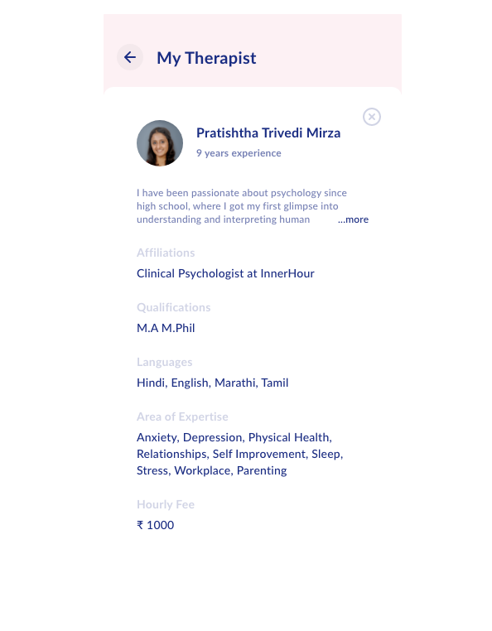

At any point if user will try to access therapist profile they will get this screen. it has only back button, which take user back to the source screen. Cross icon will close the expanded sheet.

After completing any task user should return to the source screen only.